To create virtual environment using **Conda** and **python** version **=** 3.12 (venv is name of environment)

Step 1:

open the **Command Palette (Ctrl + Shift + P),** search for the **Python: Create Environment** command, and select it**.**

Step 2: Virtual Environment **created**



Virtual environment **activated**



Wrote code in **app.py** file

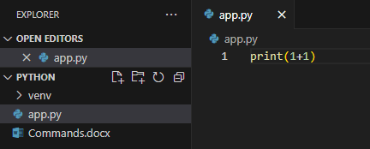

To **run** app.py file and see the output as 2



Created an **test.ipynb** file, then selected the **kernel** as ***venv(Python 3.12)***

Then it is asking the need for **ipykernel** package

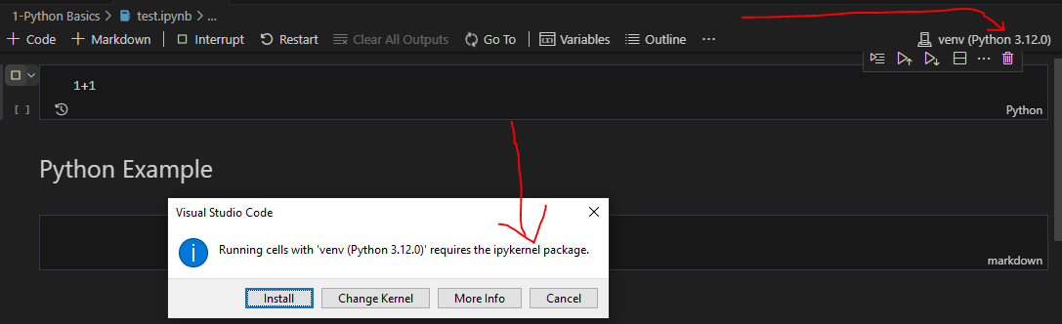

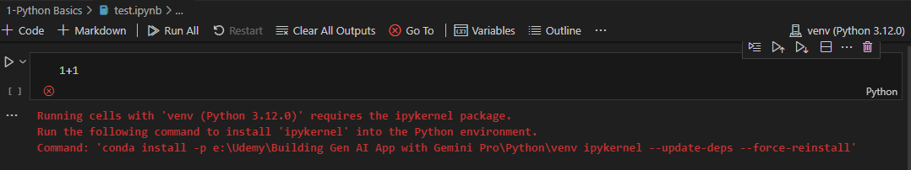

To install ipykernel



Now the code ran successfully

